# Sensors and Radio Test 2

What is the name of the sensor on the micro:bit which measures the direction it is facing?

A. Compass

B. Accelerometer

C. Thermometer

D. Bluetooth Antenna

ANSWER: A

What can a digital sensor measure?

A. A single status

B. A continuous range of values within a range

C. A continuous range of values above a certain level

D. A continuous range of value below a certain level

ANSWER: A

What will be the output from the following program if the temperature is 30

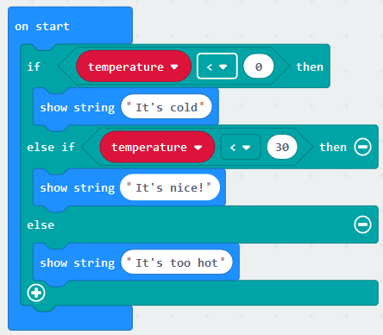

A. show string “It’s nice!”

B. It’s nice!

C. It’s too hot

D. show string “It’s too hot”

ANSWER: C

Which type of sensor would you use to automatically turn on the heating if it is too cold?

A. Infrared

B. Humidity

C. Temperature

D. Accelerometer

ANSWER: C

Which sensor could be used to control a car racing game on a phone by tilting it?

A. Infrared

B. Humidity

C. Temperature

D. Accelerometer

ANSWER: D

What is the Caesar Cipher?

A. A way of encrypting data by moving the letters along the alphabet

B. A way of sending messages from one computer to another

C. A way of encrypting data by using a prime number

D. A Roman computer

ANSWER: A

When sending messages from one computer to another data is often encrypted. Why is this?

A. It uses less of your data allowance

B. It is quicker

C. It makes it meaningless if someone intercepts it

D. So that the two communicating devices understand the rules

ANSWER: C

What is the purpose of the radio set group block?

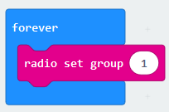

A. To send a test value ‘1’ to ensure that the devices are communicating

B. To ensure that both devices are communicating on the same channel

C. To ensure that you are able to use the blocks from radio group ‘1’

D. To ensure that only 1 piece of information is transmitted at a time

ANSWER: B

What is an IF statement an example of?

A. Sequence

B. Selection

C. Iteration

D. Loop

ANSWER: B

In which of the following stages would flowcharts be used?

A. Write down the success criteria

B. Create a test plan

C. Plan the algorithms

D. Create the code

ANSWER: C

What will the following code output?

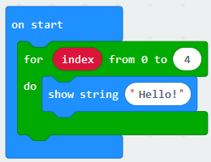

A. Hello!

B. Hello! Hello! Hello!

C. Hello! Hello! Hello! Hello!

D. Hello! Hello! Hello! Hello! Hello!

ANSWER: D

How many times will the melody ‘dadadum’ play?

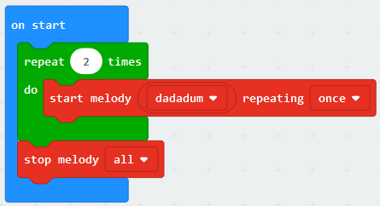

A. 1

B. 2

C. 0

D. 3

ANSWER: B

Stepan has written a simple program. It contains a bug which means that it doesn’t display the image. How can he fix this?

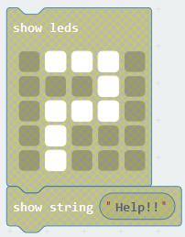

A. Place the code inside an on start loop

B. Place the code inside a forever loop

C. Place the code inside an ‘on button pressed’ block

D. Any of the above

ANSWER: D

Lucas has created a tune using blocks from the ‘music’ category. If he changes the btm value what does this result in?

A. The volume increasing

B. The volume decreasing

C. The tempo of the tune changing

D. The tone of the note changing

ANSWER: C

How many measurements of the light level will the code below take?

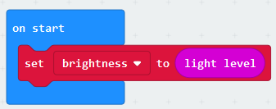

A. None

B. 1

C. 2

D. It will take endless measurements whilst the program is running

ANSWER: B

What is the name of the datatype which would allow the micro:bit to display “M6”?

A. String

B. Integer

C. Text

D. Real

ANSWER: A

Where would you find the block of code to show the image below on the micro:bit?

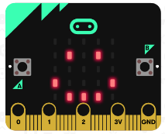

A. LED

B. Basic

C. Logic

D. Advanced

ANSWER: B

Which of the following blocks could be used to help determine which direction you are facing?

A. Compass heading

B. Light level

C. Acceleration (mg)

D. Temperature

ANSWER: A

What should we do to ensure code is as efficient as possible?

A. Include loops to avoid repeating lines of identical code

B. Use selection statements wherever possible

C. Ensure that you write the correct code first time

D. Use as many different variables as possible

ANSWER: A

If each line of code in a program always runs in the same order every time what type of statement does it not include?

A. Sequence

B. Selection

C. Iteration

D. All of the above

ANSWER: B

Question?

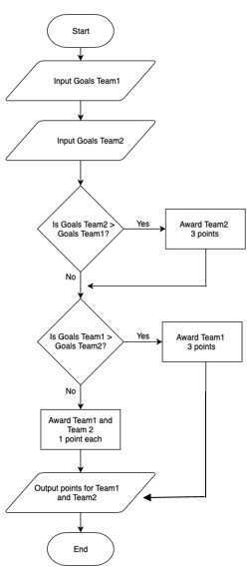

A. 3 0

B. 0 3

C. 0 0

D. Team1 0 Team2 3

ANSWER: B